**SPACE Mission Project**

**Information:**

The data set is of the “**Space Mission”**, where there are 7 companies who launched their rockets into the space with the different payloads.

**Space Missions: Modelling and Analysis**

**Introduction:**

Space has always been of keen interest to mankind as it is believed to contain information relevant to formation, existence, and continued sustenance of our planet. In this regard, astrophysics, which is an important space science, employs the principles of physics and chemistry to provide information about nature of space & objects. Similarly, astronomy, an old natural science, provides information about origin & evolution of celestial objects e.g., planets, stars, galaxies etc. using observed data. However, as terrestrial instruments have a limited reach, concept of objects in space for such tasks has evolved. Further, many Earth related activities e.g. communication, etc. also are found to be better performed with instruments positioned at higher altitudes. These have resulted in the concept of space objects to address terrestrial and space exploration needs.

**Space Mission Configuration:**

Space mission is defined as an act of transporting a space object to its designated spot and then carrying out the scientific / technological activities. In general, space objects are termed spacecraft which consist of satellites, probes, landers etc. as per the specific role assigned to these objects. Transportation of these objects is done through rockets which are also termed launch vehicles and burn a large amount of propellant to impart the required energy. Further, space mission is broadly classified in terms of ascent, orbit /inter-planetary and entry/re-entry missions. Ascent mission is the part in which space object is imparted sufficient energy to form an orbit around earth. Orbital mission pertains to the part where the object is placed in a desired orbit / put on a path to other planets. Re-entry mission is that segment in which the object is brought to planet surface in a controlled manner.

**Space Mission Segments:**

Objective of ascent mission is to provide potential (altitude) & kinetic (velocity) energy to desired payload, so that it can remain at a specified altitude above earth. This is made possible through burning of a large quantity of propellant. It should be mentioned that ascent missions are designed to perform the above task in a safe and optimal manner. Objective of orbital segment is to perform spacecraft related tasks and is broadly grouped as follows.

* Manoeuvres to achieve desired earth orbit.
* Manoeuvres to achieve desired inter-planetary path.
* Manoeuvres to achieve desired orbit around planets.

Re-entry or return is the reverse of the ascent mission, that involves recovery of space objects, without damage. The main challenge is the dissipation of large amount of energy, imparted during ascent & orbital mission phases. Problem is further complicated by the requirement of precise positioning during landing phase.

**Space Mission Design Strategy:**

Space missions aim to carry out scientific/ technological tasks so that their design is driven by the intended role of the spacecraft. However, for spacecraft to carry out the tasks, it needs to be placed at the correct location and hence, the need for a launch vehicle, for which spacecraft is just a mass. In most mission design activities, we first design the spacecraft, followed by suitable launch vehicle.

**SpaceX**

**About:**

**Space Exploration Technologies Corp.** ([doing business as](https://en.wikipedia.org/wiki/Doing_business_as) **SpaceX**) is an American [spacecraft manufacturer](https://en.wikipedia.org/wiki/Space_industry), [space launch](https://en.wikipedia.org/wiki/Space_launch) provider, and a [satellite communications](https://en.wikipedia.org/wiki/Telecommunication) corporation headquartered in [Hawthorne, California](https://en.wikipedia.org/wiki/Hawthorne,_California). It was founded in 2002 by [Elon Musk](https://en.wikipedia.org/wiki/Elon_Musk), with the goal of reducing space transportation costs to enable the [colonization of Mars](https://en.wikipedia.org/wiki/Colonization_of_Mars). It manufactures the [Falcon 9](https://en.wikipedia.org/wiki/Falcon_9) and [Falcon Heavy](https://en.wikipedia.org/wiki/Falcon_Heavy) launch vehicles, [several rocket engines](https://en.wikipedia.org/wiki/SpaceX_rocket_engines), [Cargo Dragon](https://en.wikipedia.org/wiki/SpaceX_Dragon_2), crew spacecraft, and [Starlink](https://en.wikipedia.org/wiki/Starlink" \o "Starlink) communications satellites.

SpaceX is developing a satellite internet constellation named [Starlink](https://en.wikipedia.org/wiki/Starlink" \o "Starlink) to provide commercial internet service. In January 2020, the Starlink constellation became the largest satellite constellation ever launched, and as of September 2022 comprises over 3,000 [small satellites](https://en.wikipedia.org/wiki/Small_satellite) in orbit. The company is also developing [Starship](https://en.wikipedia.org/wiki/SpaceX_Starship" \o "SpaceX Starship), a privately funded, [fully reusable](https://en.wikipedia.org/wiki/Fully-reusable_orbital_launch_vehicle), [super heavy-lift launch system](https://en.wikipedia.org/wiki/Super_heavy-lift_launch_vehicle) for [interplanetary](https://en.wikipedia.org/wiki/Interplanetary_spaceflight) and [orbital spaceflight](https://en.wikipedia.org/wiki/Orbital_spaceflight). It is intended to become SpaceX's primary orbital vehicle once operational, supplanting the existing [Falcon 9](https://en.wikipedia.org/wiki/Falcon_9), [Falcon Heavy](https://en.wikipedia.org/wiki/Falcon_Heavy), and [Dragon](https://en.wikipedia.org/wiki/SpaceX_Dragon_2) fleet. It will have the highest payload capacity of any orbital rocket ever built on its debut, scheduled for 2022 pending launch license.

SpaceX's achievements include the first privately funded [liquid-propellant rocket](https://en.wikipedia.org/wiki/Liquid-propellant_rocket) to reach orbit around Earth; the first private company to successfully launch, orbit, and recover a spacecraft; the first private company to send a spacecraft to the International Space Station; the first [vertical take-off and vertical propulsive landing](https://en.wikipedia.org/wiki/VTVL) for an orbital rocket booster; first reuse of such booster; and the first private company to send astronauts to orbit and to the [International Space Station](https://en.wikipedia.org/wiki/International_Space_Station). SpaceX has flown and landed the Falcon 9 series of rockets [over one hundred times](https://en.wikipedia.org/wiki/List_of_Falcon_9_and_Falcon_Heavy_launches).

**Analysis on the data set related to space mission by seven different companies:**

* In the data set there are seven different companies namely Arianespace, Boeing, Brazilian Space agency, European Space agency, Martin Marietta, SpaceX, US Air Force.
* The data is of the rockets launched by these companies for the different payloads from the year 1964 to 2020.
* The vehicle type, launch time, temperature at the time of launch, humidity, wind speed, Payload to orbit, Rocket height, payload name, payload type, payload mass, payload orbit, mission status and failure reasons are included in the data set.

**Analysis:**

Q1). What are the average temperature details of the launch sites?

Q2). What are the average wind speeds details of the launch sites?

Q3). What are the average humidity details of the launch sites?

Q4). What are the different varieties of launch vehicles used by different companies?

Q5). What is the mission status of the companies?

Q6). Track records of launch sites?

Q7). Number of success and failures missions by the companies?

Q8). What is the Average Payload to the payload orbit?

**Q1). What are the average temperature details of the launch sites?**

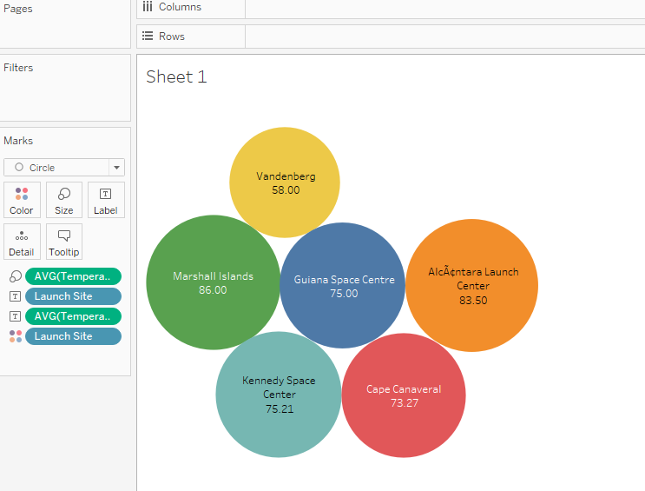

* There are basically six launch sites in the data they are Vandenberg, Marshall Islands, Guiana Space Center, Alcactara Launch Center, Kennedy Space and Cape Canaveral.
* And the average temperatures of these sites are shown above in the scatter plot.
* The highest average temperature is recorded at the Marshall Islands which is 86°c at the time of the rocket launch by the company SpaceX.
* The Least average temperature is recorded at the Vandenberg which is 58°c at the time of the rocket launch by US Air Force.

**Q2). What are the average wind speeds details of the launch sites?**

**Box Plot:** Boxplots are a standardized way of displaying the distribution of data based on a five number summary (“minimum”, first quartile [Q1], median, third quartile [Q3], and “maximum”).

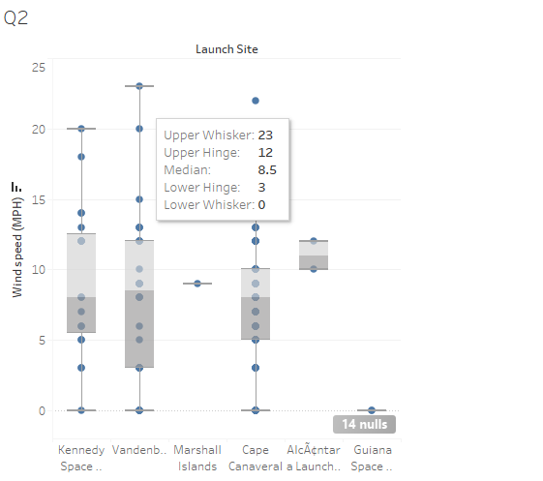

* **Median (Q2/50th percentile)**: The middle value of the data set
* **First Quartile (Q1/25th percentile)**: The middle number between the smallest number (not the “minimum”) and the median of the data set
* **Third Quartile (Q3/75th percentile)**: The middle value between the median and the highest value (not the “maximum”) of the dataset
* **Interquartile Range (**[**IQR**](https://builtin.com/data-science/how-to-find-outliers-with-iqr)**)**: 25th to the 75th percentile
* **Whiskers**(shown in blue)
* **Outliers**(shown as green circles)
* **“maximum”**: Q3 + 1.5*IQR
* **“minimum”**: Q1 -1.5*IQR
* The extreme outer dot shows the outlier.

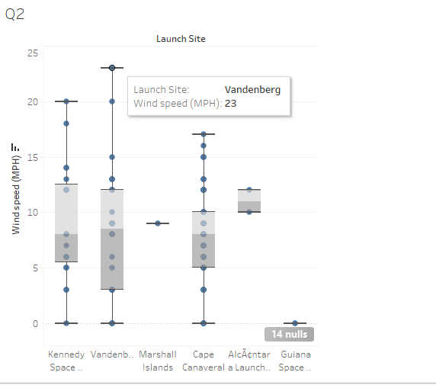

* By the tooltip we can get to know that the details of the launch site and the wind speed at that location.
* In the above case the name if the launch site is Vandenberg and the wind speed in MPH is 23.

**Q3). What are the average humidity details of the launch sites?**

**Pie Chart:** A **pie chart** (or a **circle chart**) is a circular [statistical graphic](https://en.wikipedia.org/wiki/Statistical_graphics), which is divided into slices to illustrate numerical proportion. In a pie chart, the [arc length](https://en.wikipedia.org/wiki/Arc_length) of each slice (and consequently its [central angle](https://en.wikipedia.org/wiki/Central_angle) and [area](https://en.wikipedia.org/wiki/Area)) is [proportional](https://en.wikipedia.org/wiki/Proportionality_(mathematics)) to the quantity it represents. While it is named for its resemblance to a [pie](https://en.wikipedia.org/wiki/Pie) which has been sliced, there are variations on the way it can be presented.

* There are basically six launch sites in the data they are Vandenberg, Marshall Islands, Guiana Space Center, Alcactara Launch Center, Kennedy Space and Cape Canaveral.
* And the average humidity details at the launch site are shown above in the pie chart.
* The highest average humidity is recorded at the Guiana Space Center which is 94 at the time of the rocket launch.
* The Least average humidity is recorded at the Marshall Islands which is 74.00 at the time of the rocket launch.

**Q4). What are the different varieties of launch vehicles used by different companies?**

* In the above, the launch vehicles are being shown which are of the various companies.

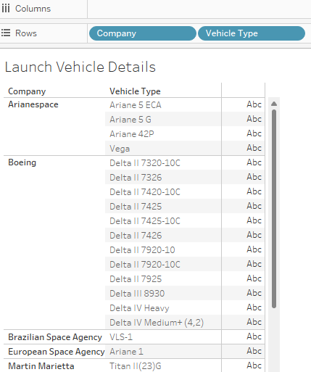

**Q5). What is the mission status of the companies?**

* In the above question, it is asked to find the mission status of the companies, that means the success and the failures of the companies after launching their rockets into the space.
* The success rate of the company SpaceX is very high comparatively with other six companies in the same domain and the total payload carried to the space is 1,354,440.
* And the failure rate of the SpaceX is very less in carrying payload to the space and the failed payload was 34,250 kgs.
* There is no success of any of the rocket by the company named as Arianspace, US Air Force, Brazilian Space agency, European Space Agency, Martin Marietta.
* The Boeing company has both success and failures.
* The payload of 93,413kgs was successfully carried to the space by the company Boeing.
* And the payload of 39,628kgs was the failed payload by the company Boeing.

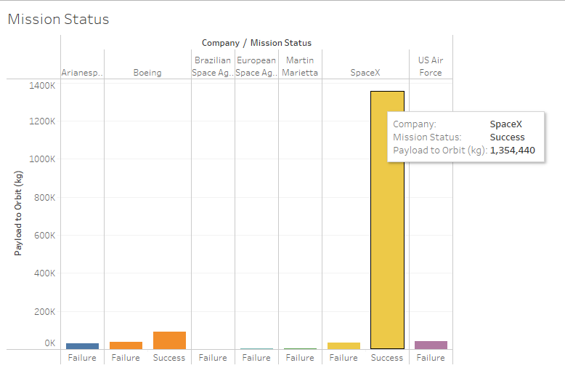

* In the above graph the tooltip shows the three items, they are Company name which is SpaceX in the selected bar, The Mission Status is Success and the Payload to the orbit is 1,354,440.

**Q6). Track records of launch sites?**

**Q7). Number of success and failures missions by the companies?**

**Stacked Bar Chart:** A stacked bar chart is a type of [bar graph](https://venngage.com/blog/bar-chart/) that represents the proportional contribution of individual data points in comparison to a total.

The height or length of each bar represents how much each group contributes to the total.

* In the above chart the stacked bar chart is used to represent the two variables in the single bar.
* In the X-axis the company names are taken and in the y-axis the Count of Space Missions are considered.
* At the first the orange colour indicates the success, and the blue colour indicates the failure.
* In the starting the company named as Arianspace has launched four space missions out of which the four missions were failed, so the success rate is zero.
* The company Boeing has launched 37 rockets in total out of which 32 were success and the rest 5 were the failures.
* The other companies named as Brazilianspace has launched 3 and all of the three were failed.
* European Space has launched two rockets and Martin Space has launched one rocket into the space and both were failures, so the success rate is zero in this case also.
* SpaceX has launched 96 rockets in total out of which 88 were the success and the remaining 8 were failed in the mission which is shown in the blue colour.
* The last company US Airforce has launched 7 rockets Into the space out of which all the seven were failed.

* The above graph shows the average rate of success and failure of all the seven companies, and which was show by the line drawn and that is 21.42.

**Q8). What is the Average Payload to the payload orbit?**

* The average payload in kg to the payload orbit is shown in the above graph.
* The highest average payload to orbit is 22,800 and which is of the suborbital and it is highlighted in dark bark colour.
* And the lowest average payload to orbit is 1,073 kg which is of Earth-moonL2 orbit, and it is highlighted in light blue colour.
* And the average of all the payloads is 10k kg to the orbit shown below.

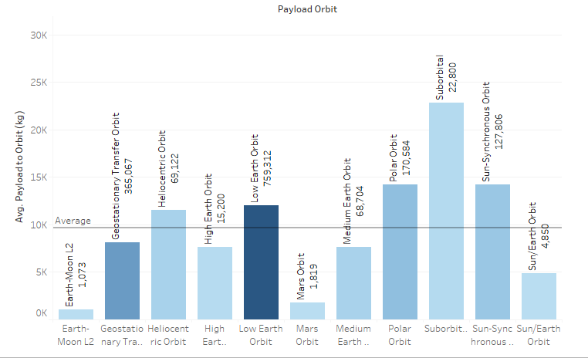

**##Dashboard**

